Submit a HydroServer feature request
Use HydroServer’s public GitHub issue tracker to propose a new feature or an improvement to an existing workflow. You can submit a request with a GitHub account and a description of what you need.
Open HydroServer Issues on GitHub

1 Sign in to GitHub
Sign in with your GitHub account and open the Issues tab in the hydroserver2/hydroserver repository.

2 Check for an existing request
Search both open and closed issues using the feature name and related terms, such as datastream filter or observed property.
If an issue already covers the idea, add your use case and any details that would help the maintainers understand it.

3 Choose Feature Request
Click New issue, then select Feature Request for a new capability or improvement. Use Bug Report when an existing feature fails and Blank issue when you need to start from scratch.

4 Describe one feature
Keep each issue focused on exactly one feature. Give it a specific title and explain which screen or workflow is affected, what you do today, what you want HydroServer to do, and why it would help. Include your version if known and attach an example or screenshot if it clarifies the request. Remove private information before posting.

5 Submit and follow the request
Review the completed form and click Create or Submit new issue. GitHub assigns an issue number and a link. Save the link, follow the discussion, and reply there if maintainers ask questions or suggest a different approach.

Example request
Title Filter datastreams by observed property
Current workflow I scan the datastream list to find water temperature records before exporting them.
Requested behavior Add an Observed Property filter so I can display only water temperature datastreams.
Benefit This would help data managers find the right records across multiple sites.

Contribute the feature code
Submitting the issue completes the feature request. Follow these additional steps if you want to implement the change yourself.

1 Discuss the proposal
Use the issue to agree on the scope with the HydroServer maintainers before beginning implementation. Keep the issue number handy.

2 Fork the repository
A fork is a copy of the project under your own GitHub account. On the original HydroServer repository page, click Fork and create the copy. For example, your copy of hydroserver2/hydroserver would live at your-username/hydroserver. GitHub keeps a connection between your fork and the original project.
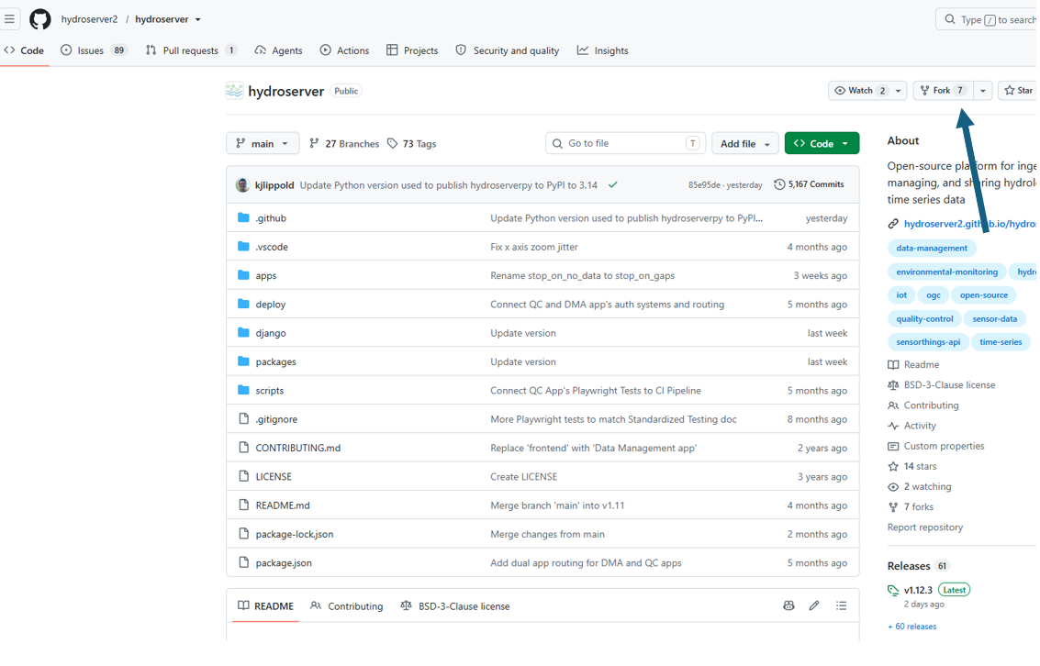
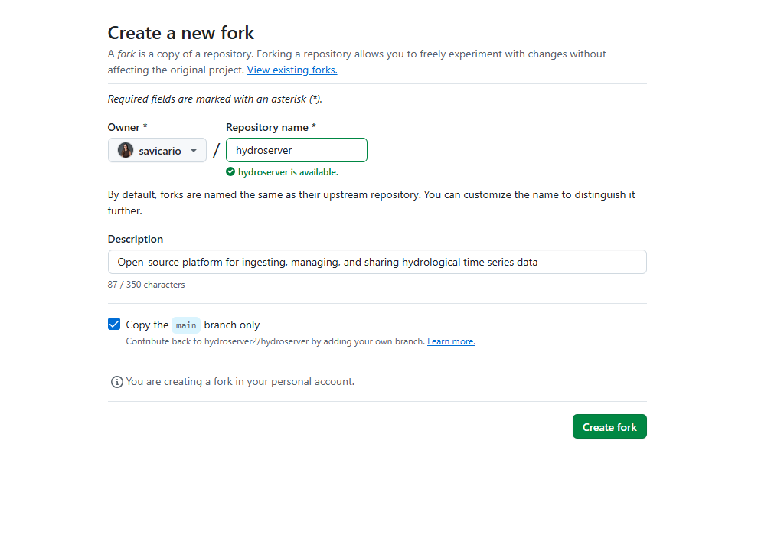
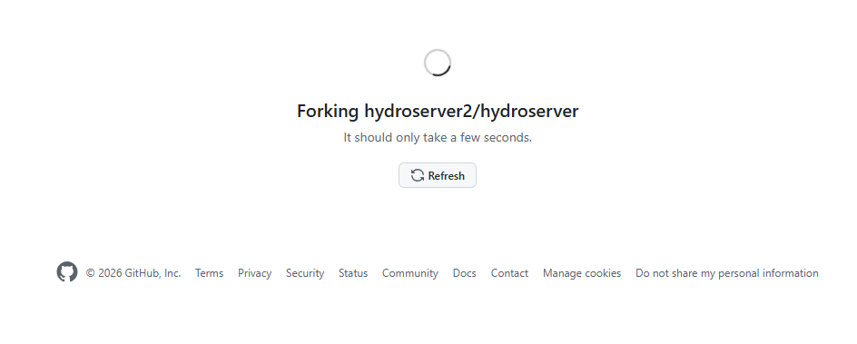

3 Create a branch
Cloning downloads your fork to your computer. A branch is a separate line of work within that copy. Create a branch for the issue, using a name such as 123-datastream-filter for issue #123.
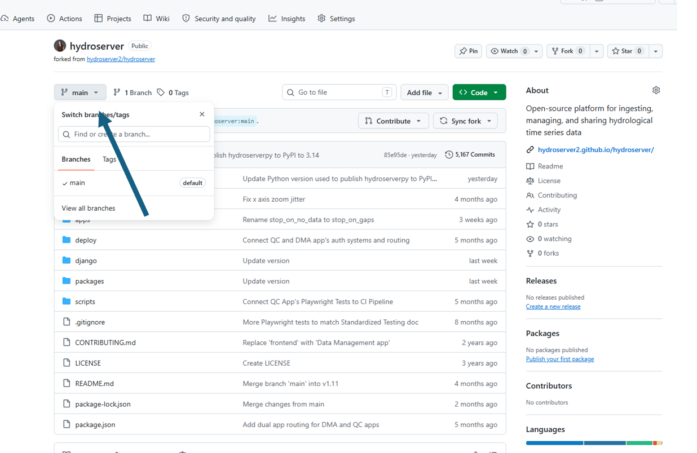

4 Install GitHub desktop
To install GitHub Desktop, go to the official download page and click Download for Windows. Once the download finishes, open your Downloads folder and double-click the setup file. When GitHub Desktop opens, sign in with the same GitHub account you used to fork HydroServer.

5 Clone your fork into your computer

5.1. Copy the URL of your fork
Open your fork on GitHub. The repository heading should show your username followed by hydroserver. Click the green Code button, select HTTPS, and copy the URL.
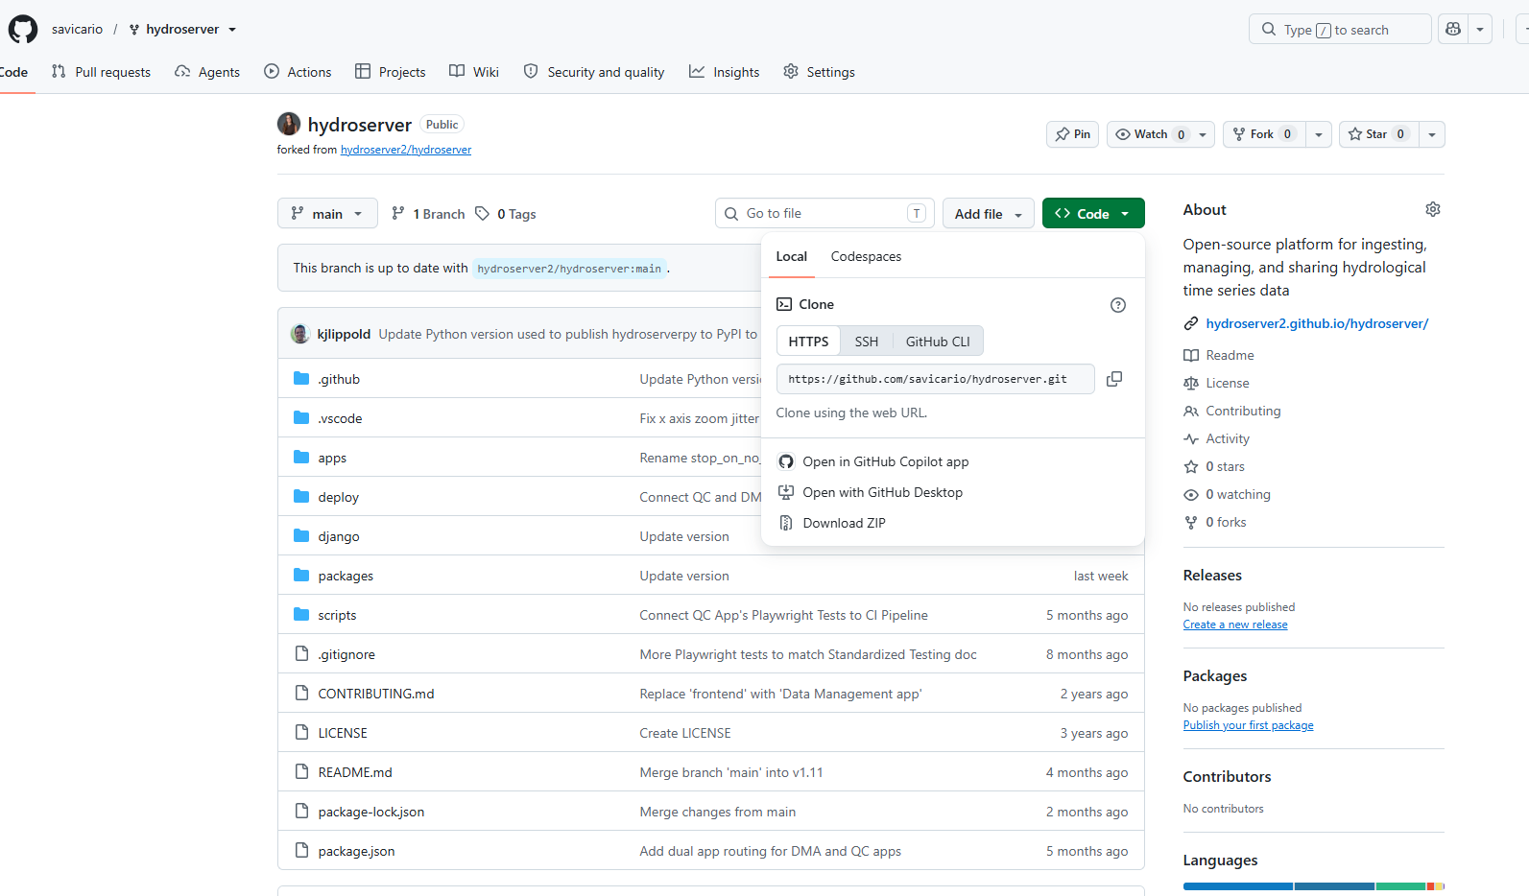
5.2. Open PowerShell in your GitHub folder
In File Explorer, open the folder where you want to keep the project. Click the address bar, type powershell, and press Enter. Git will create a new hydroserver folder inside that folder.
5.3. Clone the fork
Run the following command using the HTTPS URL you copied. Replace YOUR-USERNAME with your GitHub username if you use this example.
git clone https://github.com/YOUR-USERNAME/hydroserver.git
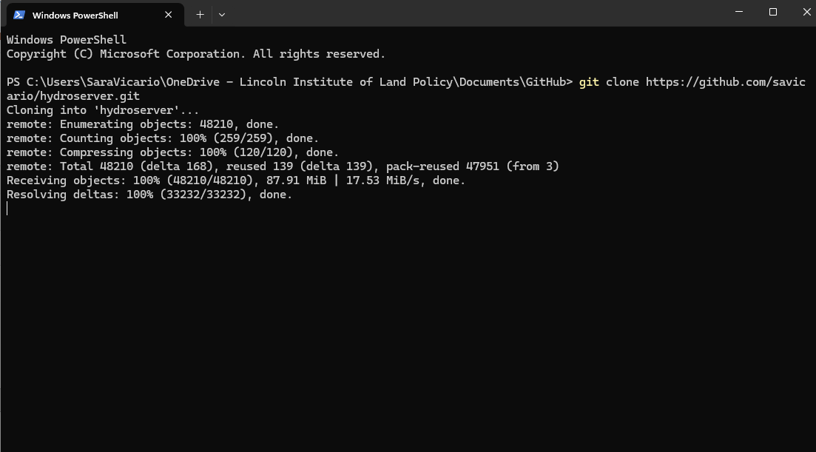
5.4 Open and verify your local copy
cd hydroserver
git remote -v
The origin entries should point to your fork on GitHub. You can now open the hydroserver folder in your code editor.

4 Implement and test the change
In GitHub Desktop, check that you’re on the branch you created for the issue. Then go to Repository → Open in Visual Studio Code to open your local HydroServer files.
Make and save your edits in Visual Studio Code. Add a test for the new feature and run the relevant tests. Then return to GitHub Desktop and open the Changes tab. Click each changed file to review your edits and uncheck any files you don’t want to include.
In the Summary box, enter a short description, such as Add observed property filter. Click Commit to [branch name] to record the changes on your computer. In Step 7, you’ll click Publish branch to upload them to GitHub.
Keep the code changes focused on the agreed feature in the branch you created.
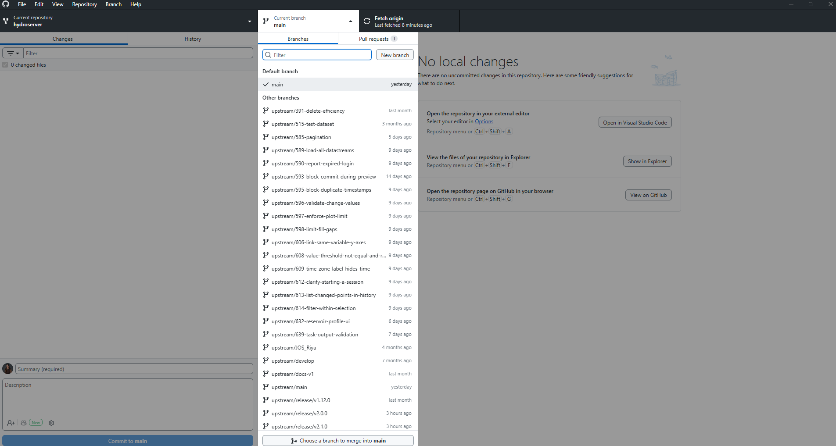

5 Push the branch and open a pull request
Push your branch to your fork on GitHub. Open a pull request from your branch into the original HydroServer repository. A pull request asks the maintainers to review and merge your changes. Link the issue, summarize the change, and note the tests you ran.
HydroServer contribution guide
GitHub guide to creating an issue

